GATE Group Session-Perseverance-October 17, 2014
Our session today started with a drawing activity. I asked each of our GATE students to try drawing this picture of a butterfly:

After giving the students about 6 minutes to make their first draft, we talked about how we can help each other improve our work by giving feedback about our drawings. I had the students team up and share suggestions on how to improve their work, and then the students tried drawing their butterflies again. I then shared with the students the following video about “Austin’s Butterfly”.
http://www.youtube.com/watch?v=hqh1MRWZjms
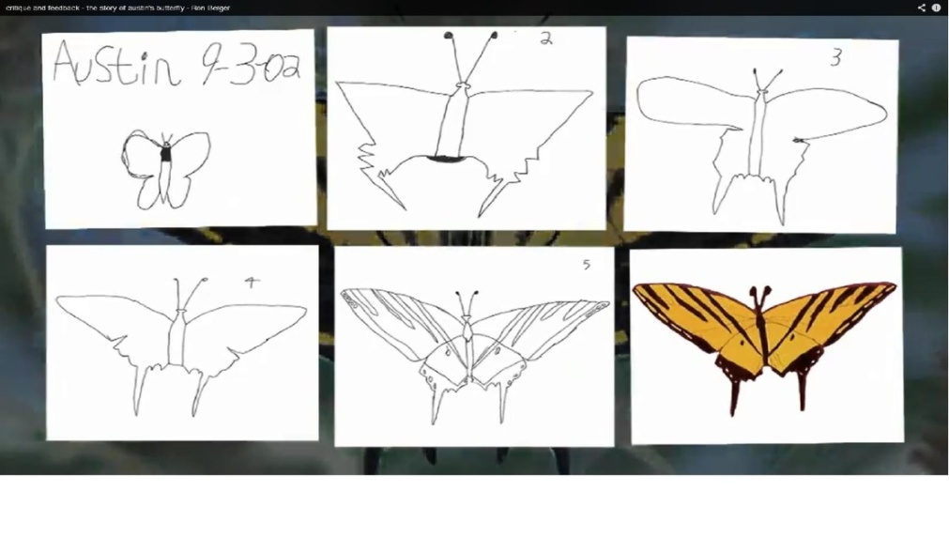
It was amazing to see how engaged your children were in watching as each of Austin’s drafts were shown. It was even more powerful for your children to hear the feedback and discussion given about Austin’s work, and how respectful the conversation and comments were. As Austin went back to use the feedback given to him, he was demonstrating true perseverance. He didn’t go back to give up, instead he used the feedback to make his drawing better. He didn’t feel defeated that he had to try again, but he was energized to make his scientific drawing more authentic and detailed.

We talked about the words that were used to critique Austin’s drawings, and how giving feedback to our peers, and how getting feedback from our parents and teachers should always be accepted as helping us to be better. It takes being a persevering person to accept suggestions from others, and to be able to use those suggestions in a positive way with positive results.
Austin proved that he was a persevering person.
Will our GATE students prove they can be persevering people as well?????

